Cuda
cudnn
설치
https://hiseon.me/linux/ubuntu/cuda-install/

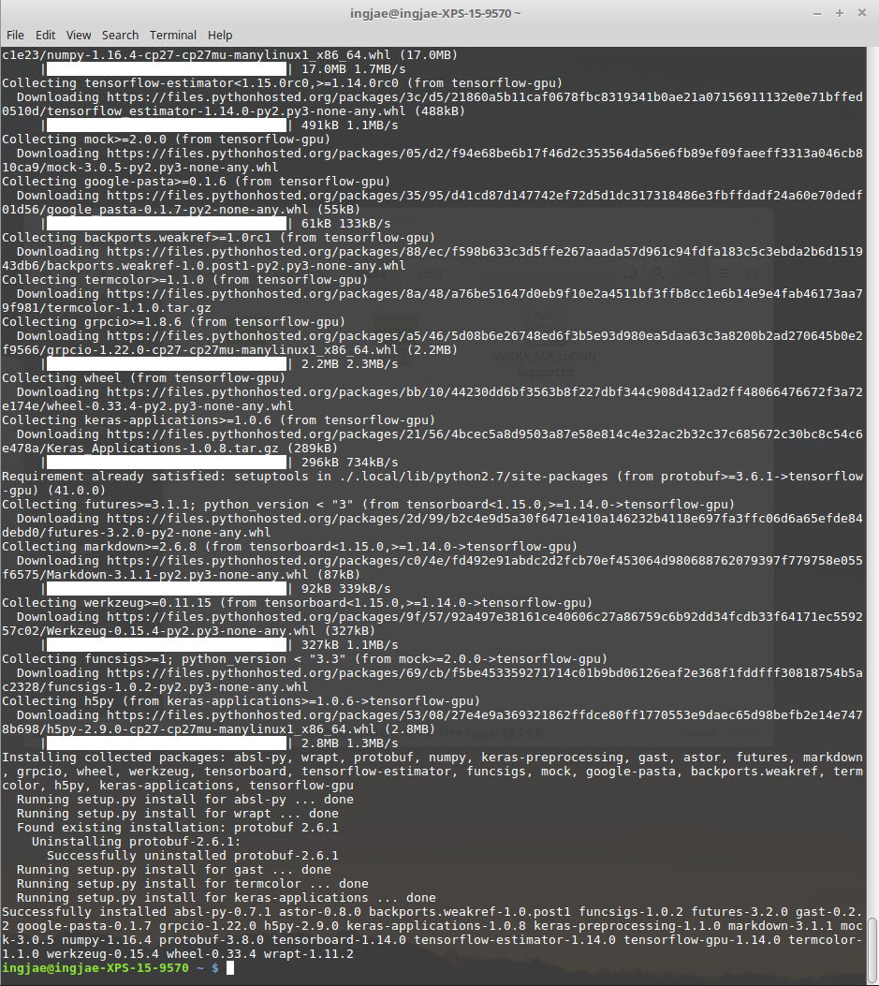
tensorflow vs 코드에서 사용하기

https://m.blog.naver.com/PostView.nhn?blogId=ljh0326s&logNo=221143094798&proxyReferer=https%3A%2F%2Fwww.google.com%2F

